Project Title: Is the London Fire Brigade's 6 minute response target being met equally across all 32 boroughs, and if not, why?

https://data.london.gov.uk/dataset/london-fire-brigade-incident-records-em8xy
- 
LFB Incident data from 2024 onwards.xlsx(74.08 MB)
Jan 2024 – Jun 2026

Grouping by year, then ordering by year to see number of accidents in a year
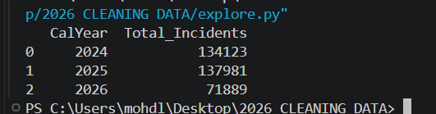

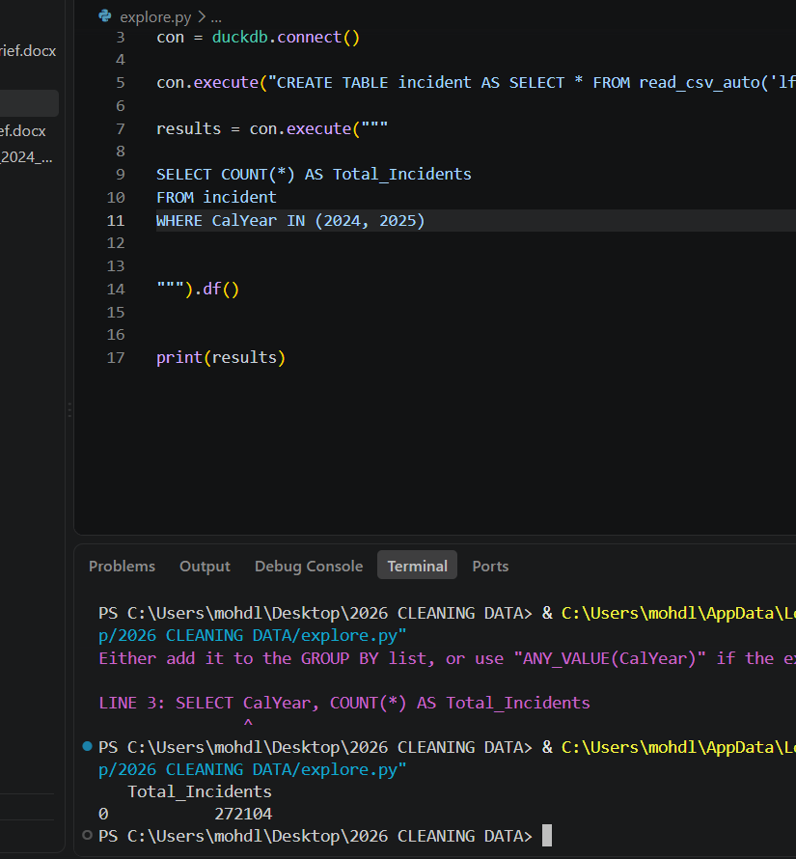

Total_Incidents has_time no_time
0 272104 258115 13989
These rows shows rows of total incidents, and that had a timing value, and no time was the row with missing or, null values

From my finding I see that hiilingdon response time is the slowest compared to any other borough. And Kensington and Chelsea being the borugh with the fastest response time.
Kensington and Chelsea came at: 274.758805 seconds average
Hilingdon came at: 384.363154 sec average
Before I thought since Hillingdon is bigger in terms of size, maybe that’s why it takes longer to reach at an incident however I was wrong. Hilingdon is said to have 7 fire stations whereas Chelsea and kensging has 5. So why is Hillingdon still slow per average?

StationComparison Total_Incidents Average_Time
0 Different Station 47355 401.0
1 Same Station 113627 286.0

When fire brigade is sent off from a different station area then it takes longer to arrive. Same station in their own area reached faster compared from another station.
401-286 = 115 seconds diffenrece. That’s massive. One of the reasons why it took longer in some areas.
Work it out from what you know about the two ends of the list.
The high out-of-ground boroughs are all inner London. Ask yourself two things:
- In inner London, when the local station is busy and a neighbour covers, how far away is that neighbour?
- In Hillingdon or Bromley, when the local station is busy, how far away is the nearest alternative?
That is the whole answer. Out-of-ground cover is not equally costly everywhere. Being covered by a station a kilometre away is very different from being covered by one six kilometres away.

